**Detonator Diagnostics Device**

**Definition:** Device that contains three scenarios built into one package to practice detonator diagnostic SOPs. Device has a transparent shelf to identify detonators and circuit construction. Inert detonators contain red LED’s to indicate when a corresponding detonator has fired.

**Hardware:** ATMega328P (Arduino)

**Input Pins:** A0 = Detonator One (~48V) = Scenario One

A1 = Detonator Two (~4.8mV) = Scenario Two

A2 = Detonator Three (~224mV) = Scenario Three

A3 = Detonator Four (~48mV) = Scenario Three

D6 = PIR output

**Output Pins:** D2 = Detonator One LED

D3 = Detonator Two LED

D4 = Detonator Three LED

D5 = Detonator Four LED

D13 = Arm Indicator

**Arming:** Toggle Switch + 10 second wait time (PIR stabilize)

**Cap Circuits:**

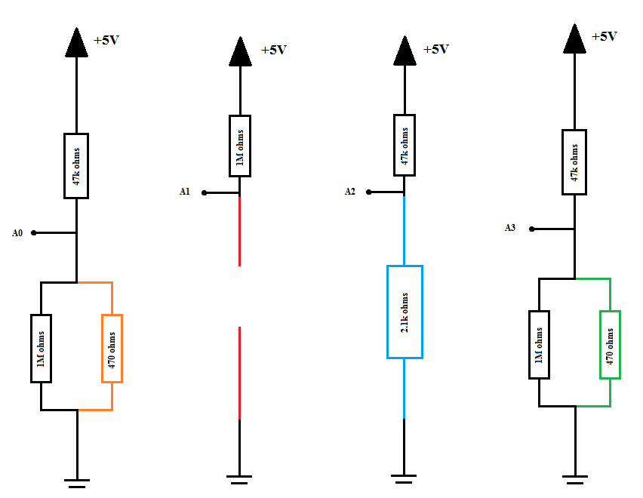

**Pictures:**

